ASSIGNMENT 4 – LAB 6: gRPC

MAIN TOPICS: gRPC, client and server stubs, RPC in general.

Objective:
Write the python code to run a gRPC server exposing methods that allow generating a "random response time" following a given distribution, with specified parameter(s), mimicking the diverse computation time of some application.
The user must be able to call the server through gRPC and generate a random response time, which must be emulated with a random sleep interval or by running a CPU-intensive task. An example of how to run a CPU-intensive task for a specified time interval is shown in the code snipped below:
import time

interval = 3.4333 # Assumed to be randomly generated
start_time = time.time()
while time.time() - start_time < interval:
x = time.time() - start_time
x = float(x) / 3.141592 # Dividing x by Pi
x = float(3.141592) / x # Dividing the number Pi by x
The gRPC messages and methods must be defined with a protobuf file. At least the following random response time distributions must be implemented at the server:
- deterministic (parameter: fixed response time)
- uniform within an interval [0:T] (parameter: size of the interval)
- exponential (parameter: mean response occurrence rate)
An RPC client program must be written to test the server behavior, following the general RPC principle to hide the distributed nature of the implementation.
OBSERVATIONS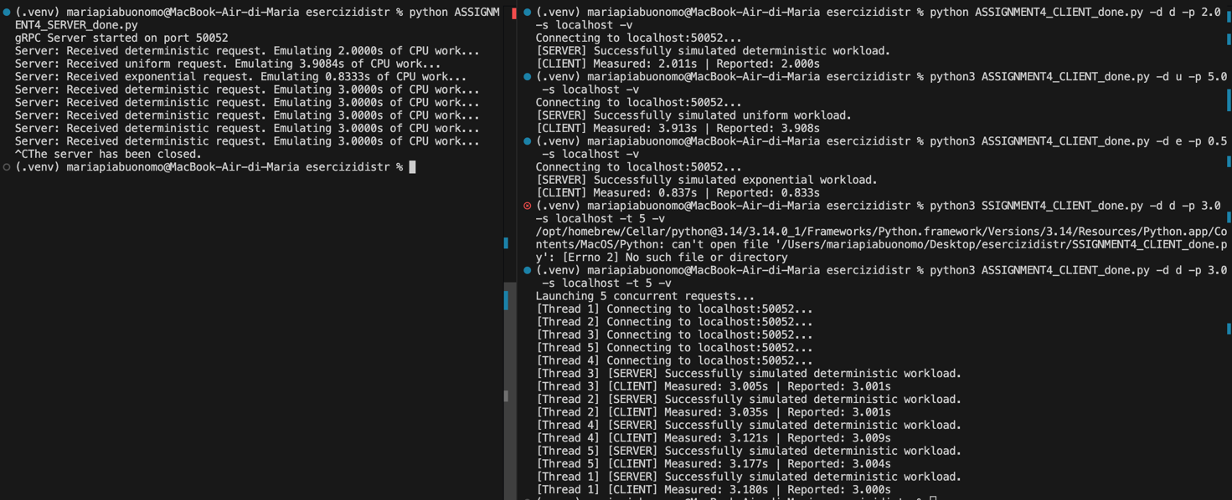
1st ATTEMPT: deterministic, uniform and exponential functions tested at the client side and the server replies. I had to change the port from 50051 to 50052 because of an error (it said that the port was already taken. I tried to kill that process that still had it active with
lsof -i :50051
But it didn’t show an output.
2nd ATTEMPT: multithreading (with the deterministic distribution for example). The reason why the server has a difference wrt the results reported by the client is because of the overhead between the two. Even if I’m working in a local host the messages have to “travel” in the OS so a minimum of latency is present. Between the threads at the client there is a little difference in ms between the actions but the server rapidly switches between them. If the server is busy the threads at the client will wait some time in the queue before being elaborated.

